**RUSH ER 7543 MDPCP Program Enrollment**

**ER Details:** Request to create some personnel fields and Orders buttons in the Program Enrollment component within the Care Management mPage. The personnel data will require a ST to auto-generate the personnel data. Please see requested changes below.

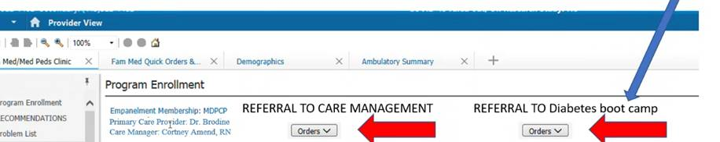

Primary Care Provider:

* For MDPCP Patients, the use label “MDPCP Provider” and display the person listed in the Person to Personnel relationship table with MDPCP Provider listed as the relationship type
* For all other patients, Attributed Provider from HealtheRegistries

Care Manager

* For MDPCP Patients, the MDPCP Provider listed in the Person to Personnel relationship table with CTO Care Manager (HEART Patient) or CTO Care Manager (non-HEART) listed as the relationship type

Referral to Care Management Order

* For MDPCP Patients, Referral to CTO Care Coordination
* For CareFirst Patients, Referral to MedStar CareFirst Care Management
* (Other Referral Orders for Care Management teams could be added other payors)

Referral to Diabetes Bootcamp

* Referral to MedStar Diabetes Pathway/Bootcamp